***TO WHOM IT MAY CONCERN***

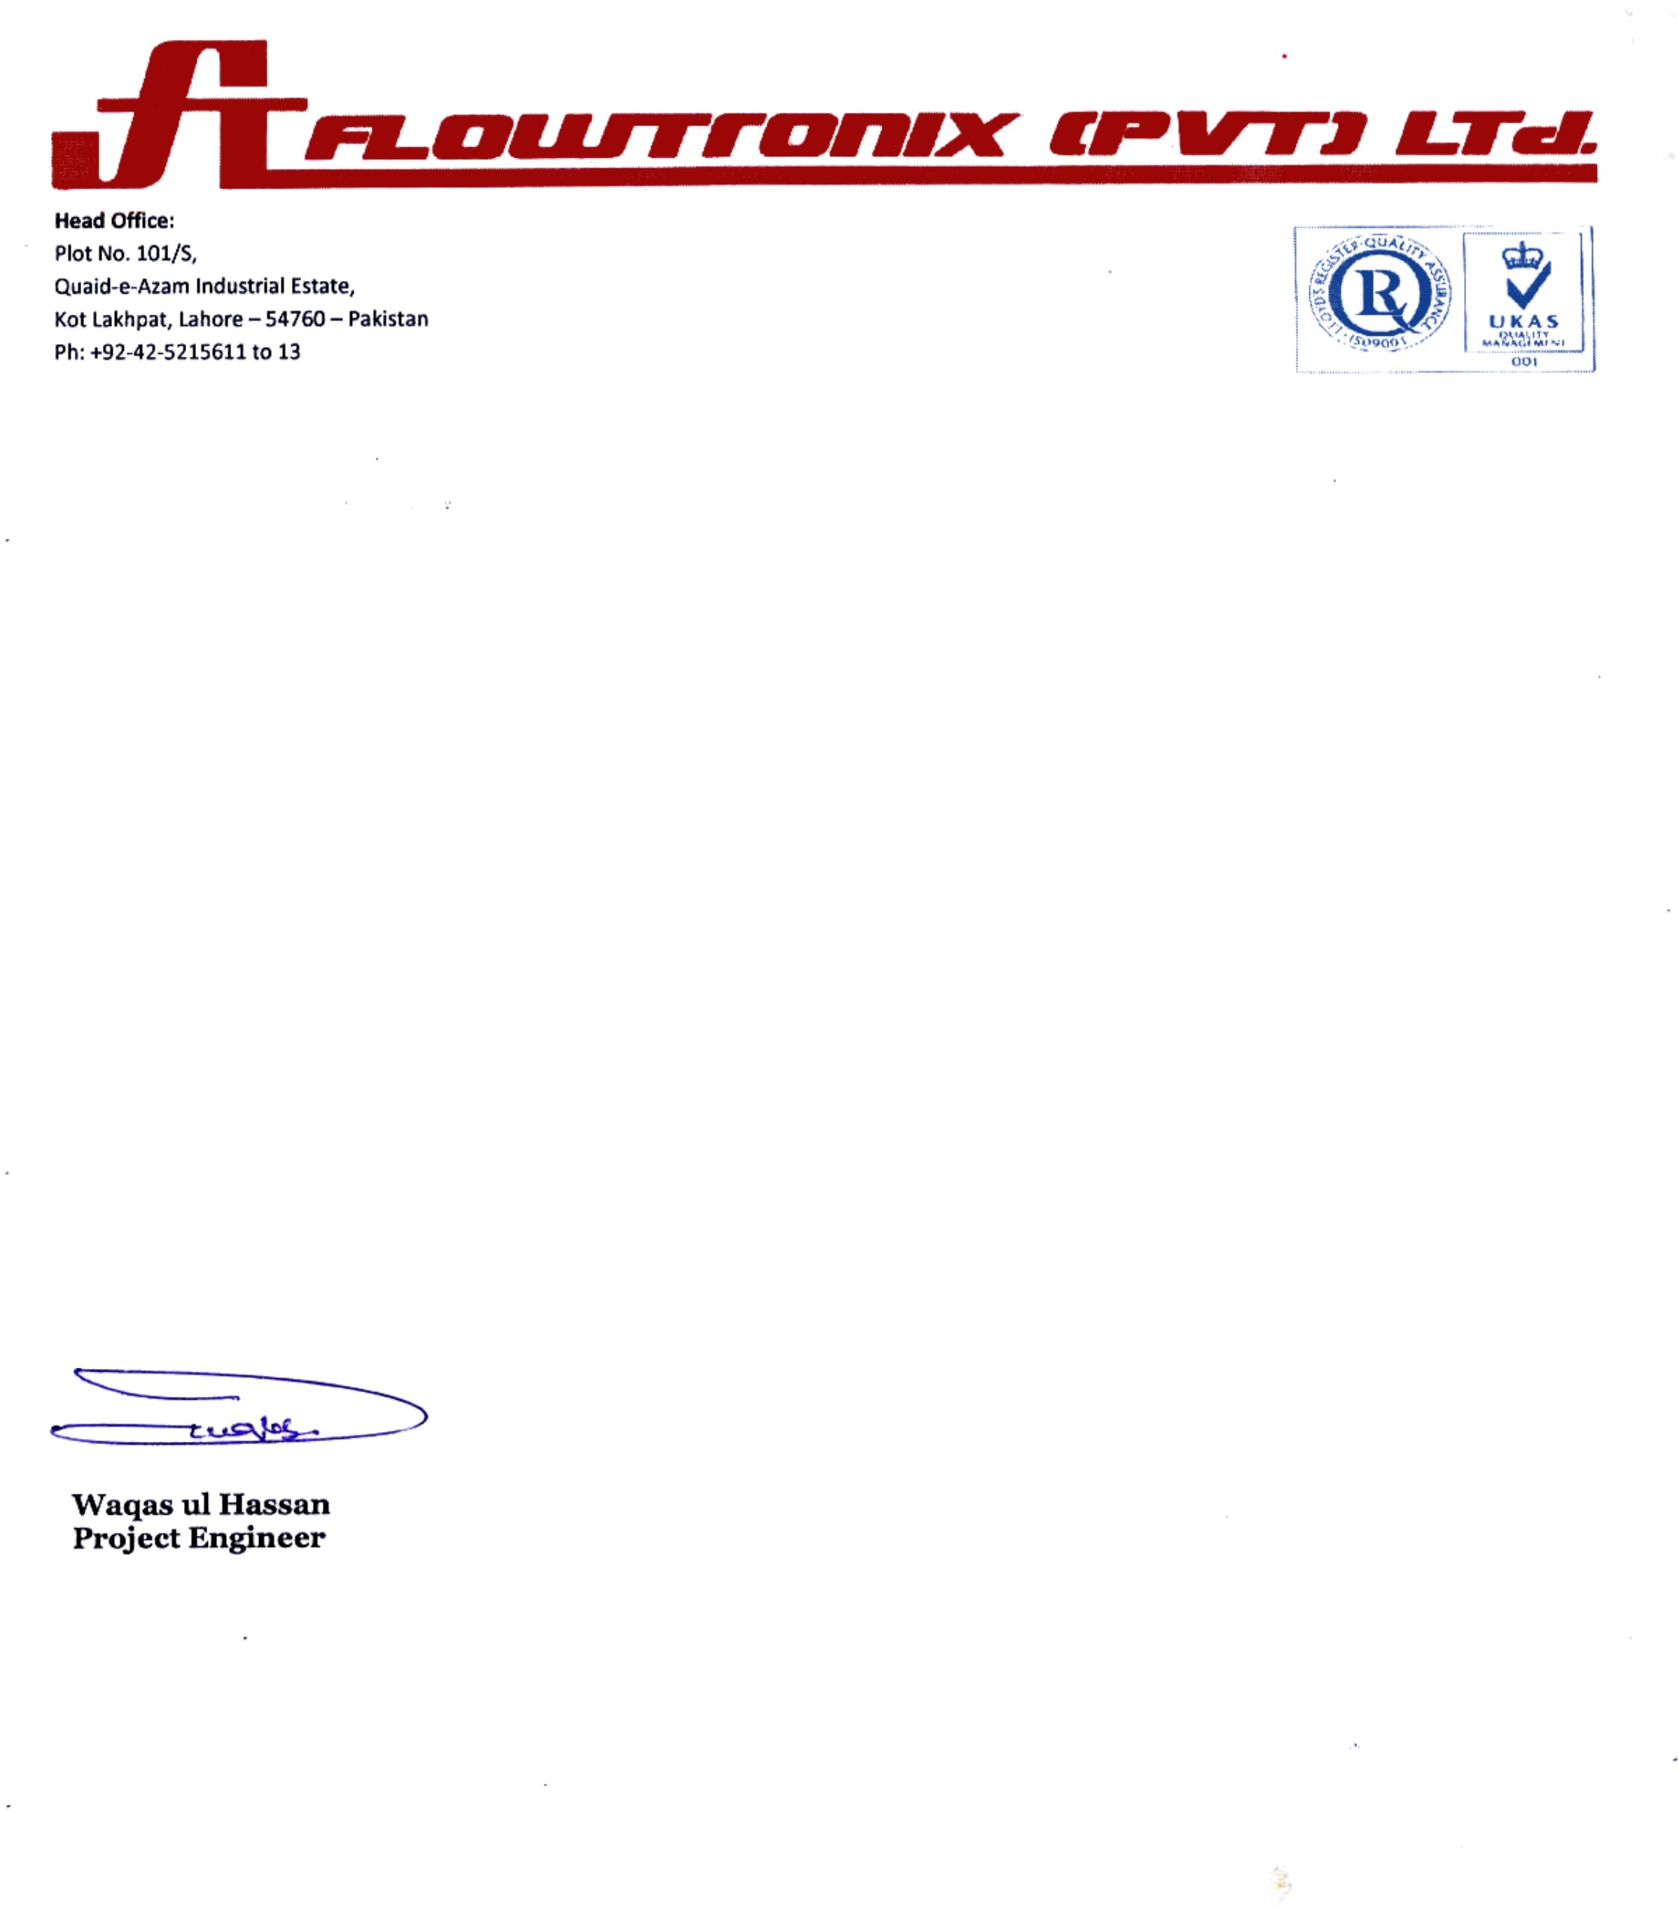

It is here by confirm that Mr. <Name> S/o <fname> was working with us as an “<Designation>” at Qadir Pur Gas Field (OGDCL) Ghotki, Sindh from <From2> to <To2>.

During his stay with us, we found him very honest, hardworking and devoted person.

We wish him success in his all future.

